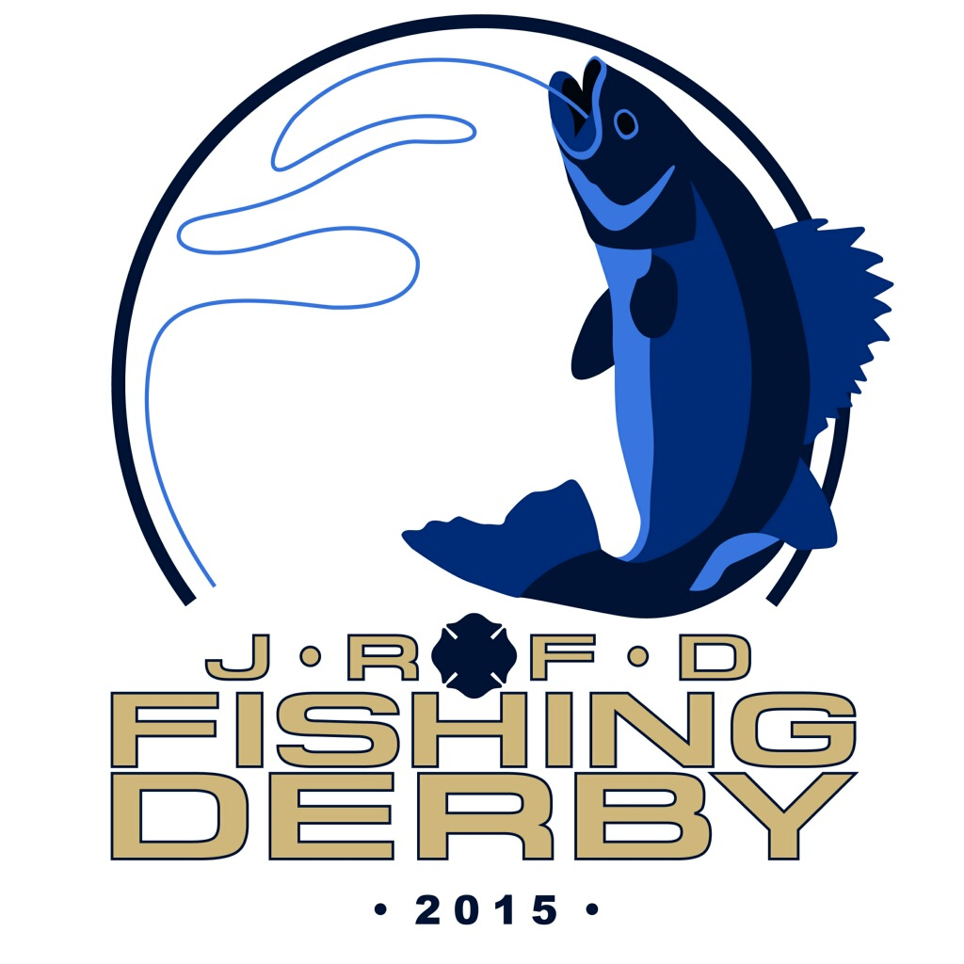
Become a sponsor for the Jamestown Rural Fire Department fishing tournament.
We hope to see you there.
February 20, 2016

The cost of the sponsorship is $250. This includes your company logo on the raffle tickets and all derby posters, also two ads in the Dakota Country magazine. Thank for your sponsorship and we look forward to seeing you out on the ice. Limited number of sponsorships available.
Company Name:_______________________________________________________________
Contact Name:_________________________________________________________________
Address:______________________________________________________________________
Phone Number:________________________________________________________________
Signature:____________________________________________________________________
Check to bill later:________________
Sponsorship amount: $_250.00_
Make checks payable to JRFD
Mail to: Jamestown Rural Fire Department
PO Box 785
Jamestown, ND 58401
For more information or questions contact Travis at (701)320-8985 or Perry at (701)320-4538

